### 4th August 2016

### YOKOHAMA launches all-new conveyor belt cover compound “Tuftex α” for mining and port customers

Tokyo – The Yokohama Rubber Co., Ltd., announced today the launch of “Tuftex α”, its newest conveyor belt cover compound. The new product is specially designed for the usage on the most demanding applications, such as high-capacity reclaimers handling iron ore and coal at port stock yard facilities. The new cover compound features YOKOHAMA’s advanced rubber compounding technology, achieving the highest level of abrasion resistance, and consequently providing longer service life. Reclaimers transport large volumes of materials in a short period of time, running their conveyor belts at high speeds, and thus subjecting the belt to severe abrasion. Reclaimer conveyors require belts that are suitable for high-severity use and are extremely abrasion resistant.

YOKOHAMA´s General Manager of Industrial Products Engineering Department said, “Our goal was to develop a new cover compound with superior abrasion resistance which would contribute to minimize downtime for our customers. By carrying out a number of field trials, using proprietary evaluation criteria, and making fine adjustments at the compound level, we were able to develop “Tuftex α” with an abrasion resistance of 64% better than our existing Super Wear Resistant (SWR) cover compound. The new belt’s superior durability also makes it ideal for prolonged use under harsh environmental conditions, such as exposure to ultraviolet rays of the blazing sun. We are currently in the process of developing another cover compound with even better abrasion resistance in order to better serve mining and port customers with unique requirement.

By introducing the value-added and high-durability “Tuftex α”, YOKOHAMA strengthens its line-up of conveyor belts and expands its market presence before the most demanding applications.

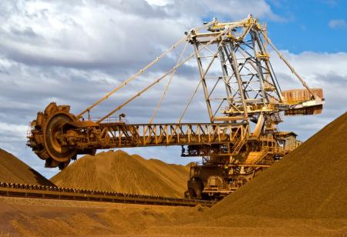

***“Tuftex α” is suitable for reclaimer***

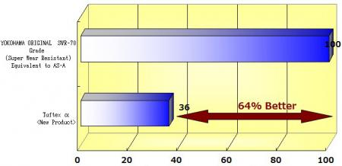

***Abrasion-resistance comparison “Tuftex α” and Super Wear Resistant cover compound (Index)***



***Brand logo of “Tuftex”***